

**Excel Assignment - 8**

1. What do you mean by AutoComplete feature in Excel and what are the benefits of using this feature?

Answer: AutoComplete helps you quickly insert functions and arguments while minimizing typing and syntax errors. The AutoComplete menu shows you available options based on context, and you choose what you want to insert into your formula. This feature examines the contents of the active column in the data directly above and tries to anticipate what you are about to type. AutoComplete is the automatic filling in of your text when you start typing and is switched on by default. This will reduce the amount of text you have to enter by preventing you typing in repetitive words. AutoComplete matches only exact cell entries, not individual words in a cell. This does not work when entering or editing formulas.

2. Explain working with workbooks and working with cells.

Answer:Select the **File** tab. **Backstage view** will appear.  
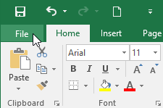

* Select **New**, then click **Blank workbook**.  
  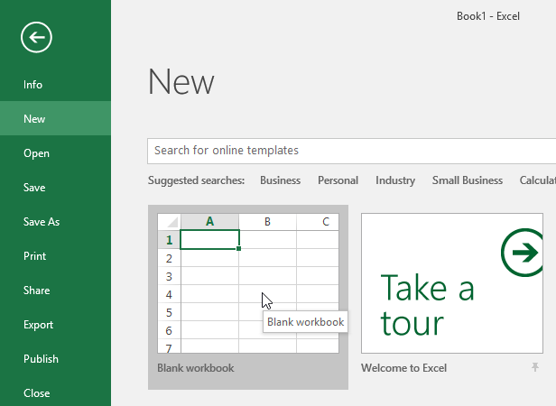
* A new blank workbook will appear.

#### To open an existing workbook:

In addition to creating new workbooks, you'll often need to open a workbook that was previously saved. To learn more about saving workbooks, visit our lesson on [**Saving and Sharing Workbooks**](https://edu.gcfglobal.org/en/excel2016/saving-and-sharing-workbooks/1/).

* Navigate to **Backstage view**, then click **Open**.  
  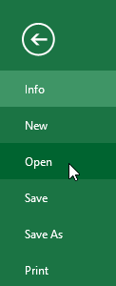
* Select **Computer**, then click **Browse**. Alternatively, you can choose **OneDrive** to open files stored on your **OneDrive**.  
  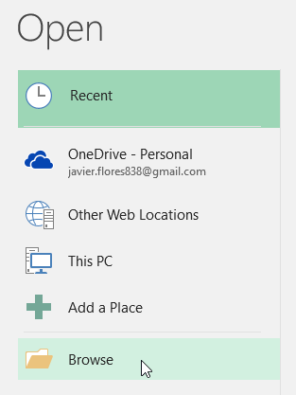
* The **Open** dialog box will appear. Locate and select your **workbook,** then click **Open**.  
  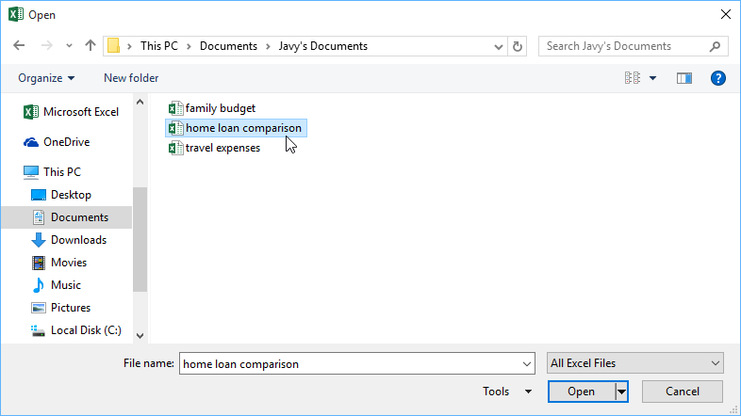

If you've opened the desired workbook recently, you can browse your **Recent Workbooks** rather than search for the file.

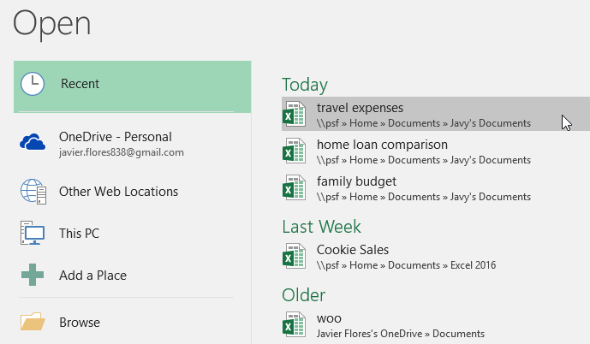

#### To pin a workbook:

If you frequently work with the **same workbook**, you can **pin it** to Backstage view for faster access.

* Navigate to **Backstage** **view**, then click **Open**. Your **recently edited workbooks** will appear.  
  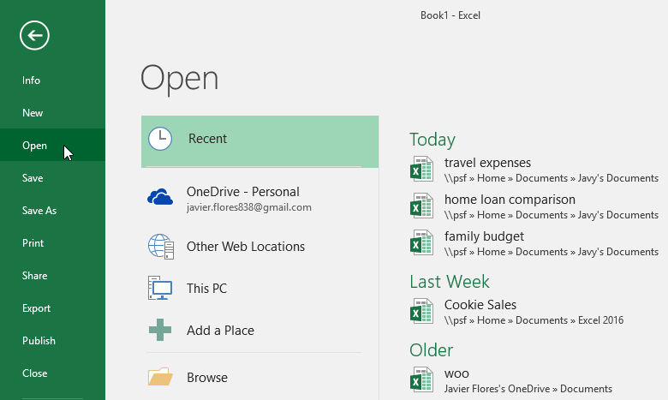
* Hover the mouse over the **workbook** you want to pin. A **pushpin** **icon** will appear next to the workbook. Click the **pushpin icon**.  
  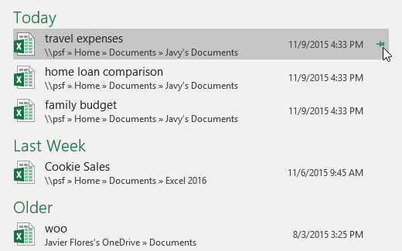
* The workbook will stay in Recent Workbooks. To **unpin** a workbook, simply click the pushpin icon again.  
  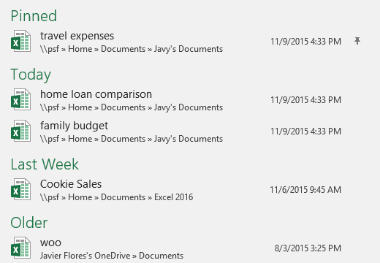

### Using templates

A **template** is a **predesigned spreadsheet** you can use to create a new workbook quickly. Templates often include **custom** **formatting** and **predefined** **formulas**, so they can save you a lot of time and effort when starting a new project.

#### To create a new workbook from a template:

* Click the **File** tab to access **Backstage** **view**.  
  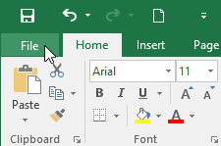
* Select **New**. Several templates will appear below the **Blank workbook** option.
* Select a **template** to review it.  
  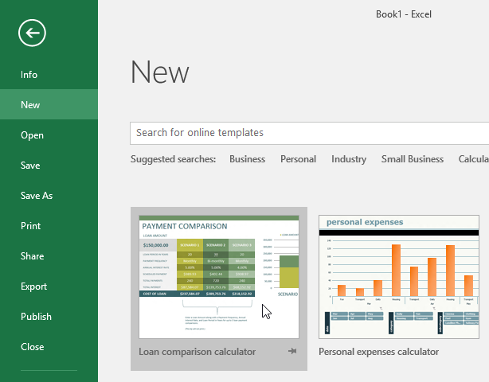
* A **preview** of the template will appear, along with **additional** **information** on how the template can be used.
* Click **Create** to use the selected template.  
  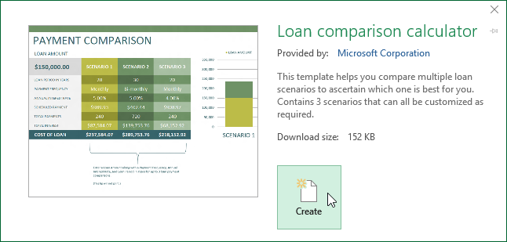
* A new workbook will appear with the **selected** **template**.

To copy and paste cell contents:

* Select the **cell or cells** you wish to **copy**.
* Click the **Copy** command in the Clipboard group on the Home tab. The border of the selected cells will change appearance.

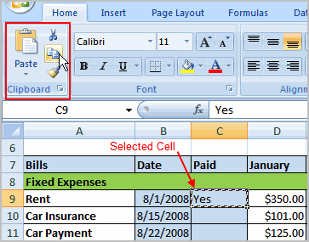

* Select the **cell or cells** where you want to **paste** the information.
* Click the **Paste** command. The copied information will now appear in the new cells.

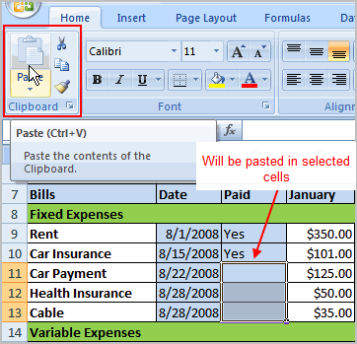

To select **more than one adjoining cell**, left-click one of the cells, drag the cursor until all of the cells are selected, and release the mouse button.

The copied cell will **stay selected** until you perform your next task, or you can double-click the cell to **deselect** it.

#### To cut and paste cell contents:

* Select the **cell or cells** you wish to **cut**.
* Click the **Cut** command in the Clipboard group on the Home tab. The border of the selected cells will change appearance.

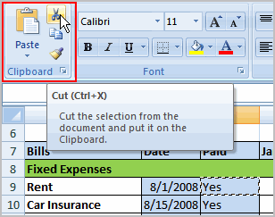

* Select the **cell or cells** where you want to **paste** the information.
* Click the **Paste** command. The cut information will be removed from the **original cells** and **now appear** in the new **cells**.

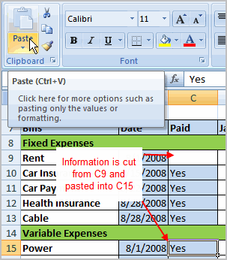

The keyboard shortcut for Paste is the **Control Key** and the **V** key.

#### To drag and drop information:

* Select the **cell or cells** you wish to move.
* Position your **mouse pointer** near one of the **outside edges** of the selected cells. The mouse pointer changes from a **large, white cross** to a **black cross with four arrows**.

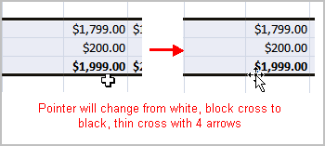

* Left-click, then **hold** the mouse button and **drag** the cells to the new location.

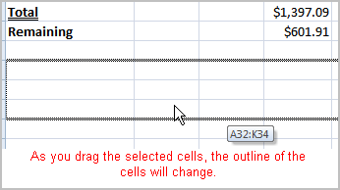

* Release the mouse button, and the information appears in the new location.

#### To use the fill handle to fill cells:

* Position your cursor over the **fill handle** until the large white cross becomes a thin, black cross.

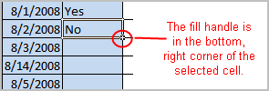

* Left-click your mouse, then **drag it** until all of the cells you want to fill are highlighted.

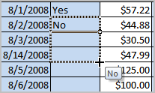

* Release the mouse button, and all of the selected cells are filled with the information from the original cell.

The fill handle doesn't **always** copy information from one cell directly into another cell. Depending on the data entered in the cell, it may fill the data in other ways. For example, if you have the formula =A1+B1 in cell C1 and use the fill handle to fill the formula into cell C2, the formula doesn't appear the same in C2 as it does in C1. Instead of =A1+B1, you will see =A2+B2

3. What is fill handle in Excel and why do we use it?

Answer: Fill Handle’ is a tool that you can use to autocomplete lists in Excel.

For example, if you have to enter numbers 1 to 20 in cell A1:A20, instead of manually entering each number, you can simply enter the first two numbers and use the fill handle to do the rest.

* Select the data set.
* Hover the mouse over the bottom-right edge of the selection, you would see a plus icon appear – How to Use Fill Handle in Excel - Plus Icon Small
* Click the left button on the mouse and drag it down. Excel identifies a pattern of the first 2 numbers (an increment of 1) and uses that to fill that entire series.

If you have data in the adjacent column, you can also hover the mouse over the right edge of the selection and double click. It will automatically fill the list to the last cell based on the data in the adjacent column.

For example, if I double-click on the fill handle (as shown below), it will fill the column till cell A11 (since there is data until cell B11 in the adjacent column.

4. Give some examples of using the fill handle.

Answer: **Autofill Numbers that Increment/Decrement by 1**

As shown above, you can quickly fill cells when the number increments/decrements by 1.

You can use fill handle in Excel to autocomplete weekday names. It could either be the three alphabets nomenclature (Mon, Tue…) or the full name (Monday, Tuesday…)

You can easily autofill dates using the fill handle in Excel. Any date format that is recognized by Excel can be used by the fill handle.

While fill handle recognizes patterns and fills the list, it also gives some additional options we can use.



5. Describe flash fill and what the different ways to access the flash fill are.

Answer: Flash Fill automatically fills your data when it senses a pattern. For example, you can use Flash Fill to separate first and last names from a single column, or combine first and last names from two different columns.

Let's say column A contains first names, column B has last names, and you want to fill column C with first and last names combined. If you establish a pattern by typing the full name in column C, Excel's Flash Fill feature will fill in the rest for you based on the pattern you provide.

1. Enter the full name in cell C2, and press **ENTER**.
2. Start typing the next full name in cell C3. Excel will sense the pattern you provide, and show you a preview of the rest of the column filled in with your combined text.
3. To accept the preview, press **ENTER**.  
   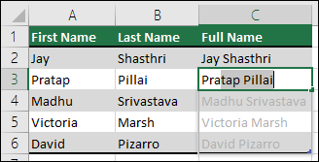  
   If Flash Fill doesn't generate the preview, it might not be turned on. You can go to **Data** > **Flash Fill** to run it manually, or press Ctrl+E. To turn Flash Fill on, go to **Tools** > **Options** > **Advanced** > **Editing Options** > check the **Automatically Flash Fill** box.

6. Extract first name and last name from the mail id and then from the address column, extract the city, state, and pin code using the flash fill. Given below is an example of the columns you have to create. Paste the screenshot of what you have created using the flash fill command.

Example: Mail Id, Address, First name, Last name, State, City, Pincode

Answer: 